4COM2006, Team Software Project   
Final Report  
Project Title: Snake+  
Student ID: 21040493

# Introduction

The main objective of our group project was to create an educational snake game that can help students around the ages of Key Stage 3 to revise mathematics quickly and efficiently while also being entertaining for the students. The main portion of the game would be a snake game which would have a question at the top of the application and multiple answers being shown on the play space where the snake game would be played. These answers would either be a correct answer or false answers. If the user were to choose the correct answer, they would be rewarded. Whereas if the user were to choose the incorrect answer they would be penalized. The game will have 3 difficulties, which decide which questions to use. Also, the game must have an element of randomness so a random question is chosen each time so the user cannot memorise the order of the game and the location of the correct answers.

We have chosen this project as we believe that it is essential that every student should be able to revise and prepare for exams in a fun yet educational manner which can help them retain information for longer and increase their skills and speed when it comes to mental mathematics.

I am contributing to the team project by creating the prototype of our project and the final product in Python. I had to do the entire code for the project due to uncontrollable circumstances only me and Jawad have been able to contribute to the group project. Due to this, I have had to manage my work while creating the product. However, I focused most on the project’s objective of creating an educational game.

## Team

|  |  |  |
| --- | --- | --- |
| Members | List of Tasks since the Interim report | Task Completed |
| Cooper | Team Leader and Code Developer   * Complete prototype game * Design the final product. * Code the snake game * Make the final product to be able to choose random questions. * Display those random questions and answers on the game. * Write and read the high score from a file and display it at the start of the game | * Yes * Yes * Yes * Yes * Yes * Yes * Yes * Yes |
| Toriqul | Project Management   * Gantt Chart | * No |
| Inthuyan | N/A |  |
| Jawad | Researcher   * Create Easy GCSE mathematic questions. * Create Medium GCSE mathematic questions. * Create Difficult GCSE Mathematic questions. * Research literature and ethics | * Yes * Yes * Yes * Yes |

# Literature and Research

Jawad took the key role when it came to researching literature for our project as he could directly use his research to implement features into our final product. His main task was to design and create multiple mental math questions to be used in our game which would complete the educational portion of our final product. He was able to complete this task by visiting multiple math-based websites with example questions on them which he could take inspiration from this and create his questions.

We both still believe that our project is essential for some students to be able to pass their Math GCSE as some students struggle with time in their exams. Using our game, the students can retain knowledge more efficiently than conventional methods such as quizzes or reading. This is backed up by a source mentioned in my interim report completed by Chris Preist and Robert Jones (2015). Their study reported that students who used a game to revise for a test scored higher marks compared to students using quizzes or not revising. This is because games are a more interactive method of revision using memory retrieval methods of revision and quizzing the student’s ability. These methods of revision succeed in allowing students to score higher due to better knowledge preservation and preparation. Retrieval practice has been studied and proven to help students score higher however they must take breaks in between studies (Gurung and Burns, 2019). Students who are active and quiz themselves also receive better exam results compared to students who just read and do not undertake interactive revision techniques (Kornel and Son, 2009)

# Methodology

With our project, there is quite a serious ethical issue due to our main target audience being students in their final years of secondary education. Some students might think that our game will be sufficient revision for their math exams. However, this is not the case as we still advise students to undertake multiple other revision strategies. Our game only focuses on the mental aspects of the math course. This means students would still be underprepared for their exam if they were to only use our game as their revision tool. This doesn’t mean our project isn’t useful though as it will still be able to improve the retention of knowledge and skills which can be effectively used in their exams.

I tried to use Agile as my type of project management, however, before I could use an Agile method of management, I had to undergo decomposition on the main problems for the project, working out how to implement each sub-problem into code so I would be able to develop the main project. This involved deciding which GUI I should use for the Python program, creating the main menu, and files for the questions to be used before I could start creating the game. The creation of the snake game was where the Agile methodology was undertaken as I was creating the game in sprints. My first sprint was being able to get the snake to move forward but the tail was increasing in size and allowed the user to change direction. My second sprint was to stop the snake from getting larger each time it moved and added boundaries to end the game. My third sprint was adding space for the questions. These sprints continued until I created a simple snake game without any educational elements. Once this was done, I implemented the reading of files which contained the questions and answers and displayed the correct answer on the correct square. Then I implemented the false answers which would negatively affect the user’s score and lives.

I could have improved my management process by writing down and documenting my process on the sprints so I could easily plan out which parts I can improve for the next sprint, however in the end the project still was completed with my design ideas and still followed my flow chart from my interim report.

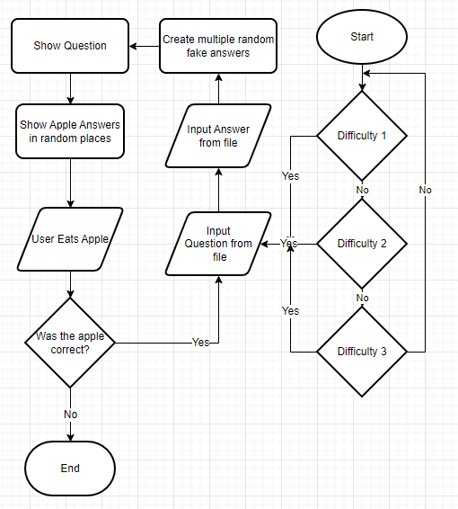

Figure - Flow Diagram of Game from Interim Report

Figure 2 – Flow Diagram of Completed Game

As a group there was not much management among the group members as there was only me and Jawad who was working on the project so I gave him ideas and tasks for him to do and he had to manage them himself, and once he was done, I would check. However, it would have been easier if our other team members contributed to their roles.

I was able to create the game using Microsoft’s Visual Studio Code as it was much easier for me to code and debug the code than on Python IDLE. This is because it would highlight errors within the code and display the line of error when the program was to crash. Also due to the colour coding of the text on the code, it was much easier to write and check over to code to make sure it was working properly.

# Implementation of the System

I started working on the concept for our project before our interim report. It was a simple snake game that had 3 incorrect mice and one correct apple, eating the apple would increase the score and snake length whereas the mice would decrease the score.

The final product works exactly as planned, with the questions appearing at the top along with the lives and current score, and each of them would update as the user touches an answer, changing their score and lives appropriately along with a new question and new answers in different locations. The snake would move at a reasonable pace where it isn’t too slow yet isn’t too fast and has a certain body length depending on how many questions have been solved correctly. If the user was to touch their tail as the snake, go through the edge of the map, or run out of lives the game would end. When the game ends, the program would detect if the user’s current score is higher than the current high score and if so, it would rewrite the high score in the high score file. The high score would be displayed on the main menu when the game is first started.

When the game is started the user has 2 choices to choose from: “Start Game” which will lead them to the difficulty options and “End Game”. Which will close the game. When the user starts the game, they will be given 3 more options, easy, medium, and hard difficulty. Depending on what difficulty the user chooses, it will read its respective question file and answer file and add the contents to the question array and answer array to be used.

I coded every aspect of the game, whereas Jawad wrote the questions and answers to be used within the game.

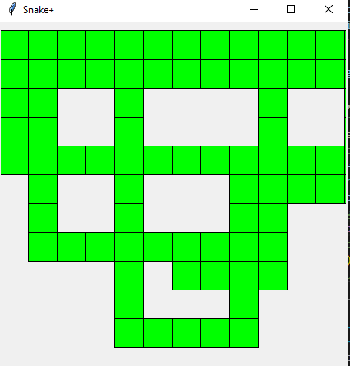

Figure 3 - Instance 1

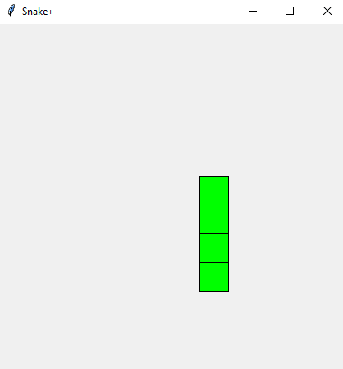

Figure 4 – Instance 2

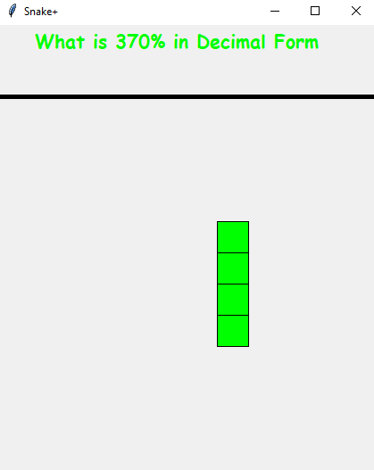

Figure 5 – Instance 3

Figure 6 – Instance 4

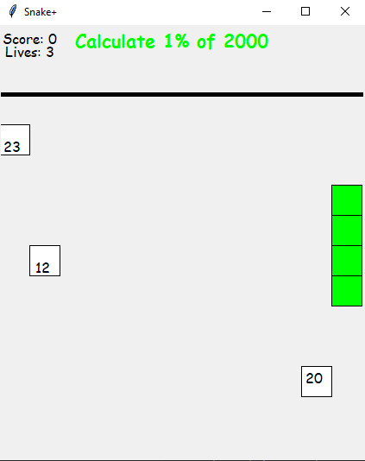

Figure 7 – Final Instance

# Evaluation

I believe our final product has achieved its main objective of being an educational game where students can practice their GCSE mental math skills to help them prepare for their GCSE exams. The game is still entertaining to play, and the game can run fine without any crashes. My contribution to the work of this team is every part of the planning, designing, prototyping, and creation of the final product. As two of our teammates didn’t contribute to our work, I could have improved our project by managing the product more efficiently and spending more time in the design phase so I could have drawn up an example of what the game is supposed to look like before going onto the prototype.

I could have tried to reach out to my other two teammates more however I have asked them for some tasks to be done and they have never been completed still. I should have been harsher with following up on them to assure that the work was done.

The project could still be expanded as well. This could be done by using randomly generated questions. As the questions are only being retrieved from files depending on the level, there is a finite number of questions so once you have completed all the questions, they would just repeat themselves in a different order with false answers. This means the student could just learn the answers rather than the correct method to solve the question. But due to time and team restrictions, the current method was needed to complete a final product. Questions and answers can still be added to their respective files so more questions can be used in the final product. Also, more questions could be added to the “Hard” difficulty as there aren’t as many questions compared to the other difficulties.

# Conclusion

In conclusion, I have learned many skills relating to Tkinter and Python, along with project management strategies and what it is like to work with a group in the real world. I have also experienced a lot of scenarios when creating a game, for example where you can be so close to finishing the game, but one minor error in the code is stopping the game from working and skills such as creating text to display and binding keys from keyboard to functions in Python.

As Team Leader I have learned that team members may be a part of your team but that doesn’t mean they will contribute to the team. Jawad and I have successfully created a functional final product and we are proud of what we have accomplished. In the future, I will ensure that I will make my team members contribute an equal amount to the project, rather than nothing at all.

# Appendix

GitHub - <https://github.com/CxxperL/SnakePlus>

Total Minutes of Meetings: 395 minutes.

## References

Preist, C. and Jones, R. (2015) ‘The Use of Games as Extrinsic Motivation in Education’, in *Proceedings of the 33rd Annual ACM Conference on Human Factors in Computing Systems*. New York, NY, USA: Association for Computing Machinery (CHI ’15), pp. 3735–3738. Available at: <https://doi.org/10.1145/2702123.2702282> [Accessed: 12 April, 2023]

Gurung, R. A. R. and Burns, K. (2019) ‘Putting evidence-based claims to the test: A multi-site classroom study of retrieval practice and spaced practice’, Applied Cognitive Psychology, 33(5), pp. 732–743. Available at: <https://doi.org/10.1002/acp.3507> [Accessed: 12 April, 2023]

Kornell, N. and Son, L. K. (2009) ‘Learners’ choices and beliefs about self-testing’, Memory. Routledge, 17(5), pp. 493–501. Available at: <https://doi.org/10.1080/09658210902832915> [Accessed: 12 April, 2023]